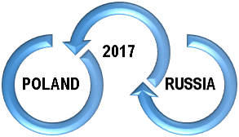
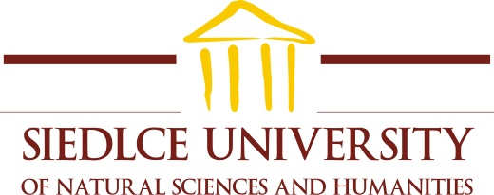
08-110 Siedlce, ul. Żytnia 39, tel./fax (25) 643-18-62, 643-18-63, e-mail:bezpieczenstwo@uph.edu.pl

REGISTRATION FORM
to attend
IV International Scientific Conference about Polish-Russian relations
under the title:
Integration or disintegration of the contemporary international environment?

The event will take place November 9-10, 2017
at Faculty of Humanities
of Siedlce University of Natural Sciences and Humanities
(39 Zytnia Street, Siedlce)

First and last name: …………………………………………………………………………………………………….....
Academic Title/Degree: …………………………………………………………………………………………………….....
Work place (affiliation): ………………………………………………………………………………..……………………...
The Title of Scientific Paper: …………………………………………………………………………………………………….....
Abstract (max. 1000 signs):
……………………………………………………………………………………………………….……………………………………………………………………………………………………….……………………………………………………………………………………………………….……………………………………………………………………………………………………….................
Phone number: …………………………………………………………………………………….............................
E-mail: ……………………………………………………………………………………………………….
Address for correspondence: ……………………………………………………………………………………………………….

Applications for participation in the seminar should be sent to the e-mail address: polska.rosja17@gmail.com or by mail to the address of Social Sciences and Security Institute in Siedlce.
The deadline for applications: October 25, 2017.

PERSON AUTHORIZED TO CONTACT
Marta Stempień, MA
mob. +48 515 814 351
e-mail: polska.rosja17@gmail.com

The fee for participation 390 PLN (95 euro) in the seminar needs to be paid by November 1, 2017 on the account number 19 1240 2685 1111 0000 3656 3195 - Bank Pekao, I Oddział Siedlce, in the title of transfer please write your name and surname
with the note: Polish-Russian Conference.
Additional opportunities for participation in the conference:
- I day – 250 PLN (we provide: conference materials, coffee breaks, dinner, evening gala dinner);
- II day – 200 PLN (we provide: conference materials, coffee breaks, dinner);
- Publication in the post-conference monograph – 150 PLN.

Organizers do not provide or book accommodation.

Participants who want to receive a VAT invoice, please provide the data:
Name of Institution: ……………………………………………………………………………………………....
Payer address: ……………………………………………………………………………………………....
NIP number of the payer: ……………………………………………………………………………………………....
Address for sending invoice: ……………………………………………………………………………………………....
VAT invoice [ ] please send by mail, [ ] I will pick during the conference

Participants from abroad wishing to obtain a visa to Poland please send us the following data, as soon as possible:
- a clear, readable scan of your passport;
- address of the consulate, to which the request for a visa should be addressed;
- home address, on which an invitation to participate in the seminar and the request to the consulate will be sent.

